Usecase Description:

Library4You is a library management system located across multiple states in the United States, founded in the year 2000. It improved providing the book(s) service to customers from physical store to retail through multiple ways like physical books and e-books. There are multiple ways a library member can search for a book using Genres, Publishers and Authors. In addition to books, there are magazines, newspapers, media, research topics, journals etc. provided to customers. Library Management also helps to manage the library by keeping a track of books rented and purchased.

Books are supplied by multiple vendors that are maintained in the system, who provide different publications of books or materials. Based on the majority of sales for a particular publisher or author, quantity of requirement for those materials from vendors will increase. A librarian is responsible to maintain the library using the online system

The process of placing an order or availing service from Library4You will start with the customer membership. Customers have the following membership options like gold, platinum or regular membership which is valid for 6 months, 18 months and 90 days respectively. Members can either purchase or rent a book or materials through on-line or from the store. A gold member can take up to 5 books per month on rent, platinum up to 12 books per month and a regular member can avail 3 books per month. Order details will be available to members which also includes tracking details of the shipment. Members can provide rating, review for a particular order placed and also the feedback for the services provided by Library4You.

Library Management system allows the company to maintain information about customers, tracking details, inventory details which will improve the efficiency of the company. It can also gather and procure more quantities of books based on the orders placed and based on the trending topics of market. Library4You requires an effective database system to keep track of all the activities which will scale their operations and satisfy customer needs and services across locations.

**Entities:**

Store

Membership

Member

FeedBack

OrderDetails

Order_Rating

Rental

Purchase

Shipment

Ebooks

Books

Suppliers

Supplier_Publishers

Publishers

**Assumptions:**

Store can give one or many memberships but membership can be taken from one and only one store.

A supplier can get books from multiple Publishers based on the demand and a publisher can supply books to many suppliers, as such Suppliers_Publishers serves as a bridging entity

Feedback can be give by one member and member can give many feedbacks.

Member can take one and only one membership and multiple memberships cannot be given to the same member.

Order can have many books/ebooks in it but a book/ebooks belongs to a single order.

Feedback is given to one order and order can have many feedbacks.

Members can take a book on rent or purchase a book on-line

**Entity Relationship Diagram:**

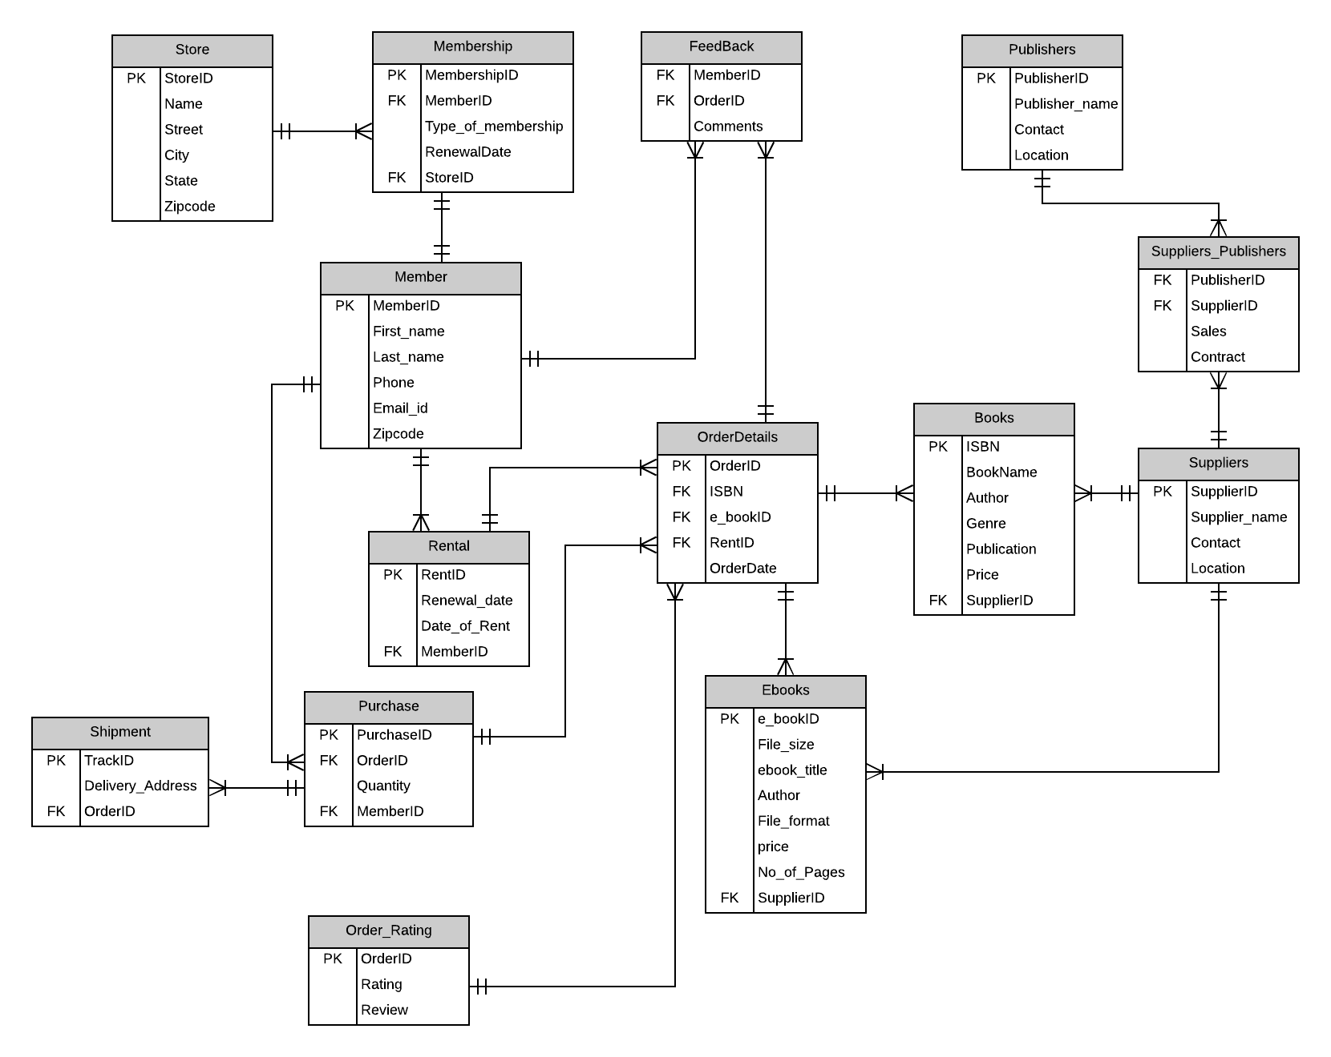

Database Diagram:

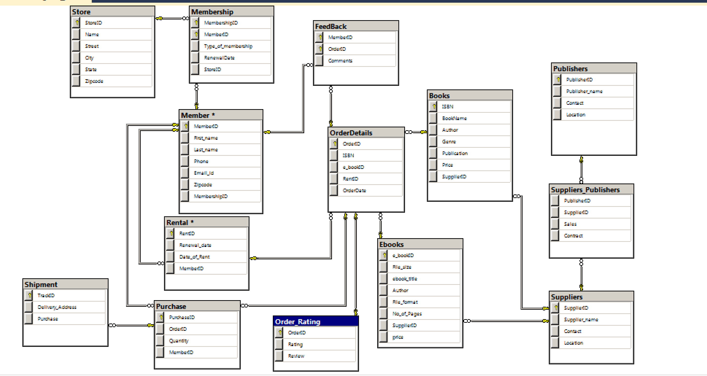

Queries:

1.List of Members for each store

SELECT m.First_name+' '+m.Last_name as member_name

,s.Name as store_name

FROM Member m

JOIN Membership ms

ON ms.MemberID = m.MemberID

JOIN store s

ON s.StoreID=ms.StoreID

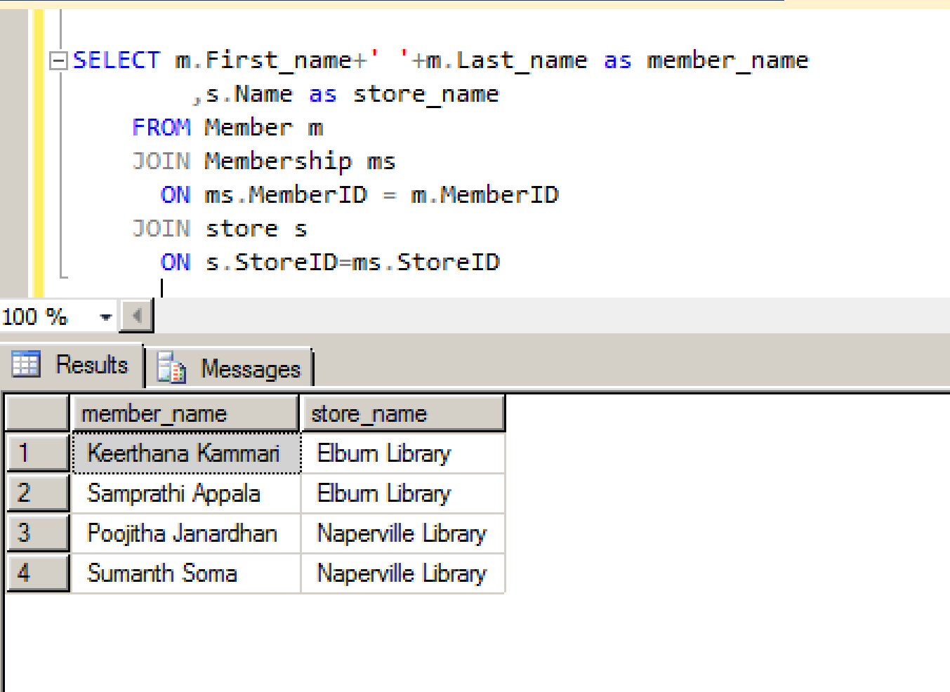

2.Members with Date of rent

A.select m.First_name+' '+m.Last_name as Name,Date_of_Rent,Renewal_date

from Rental r JOIN Member m

on r.MemberID=m.MemberID

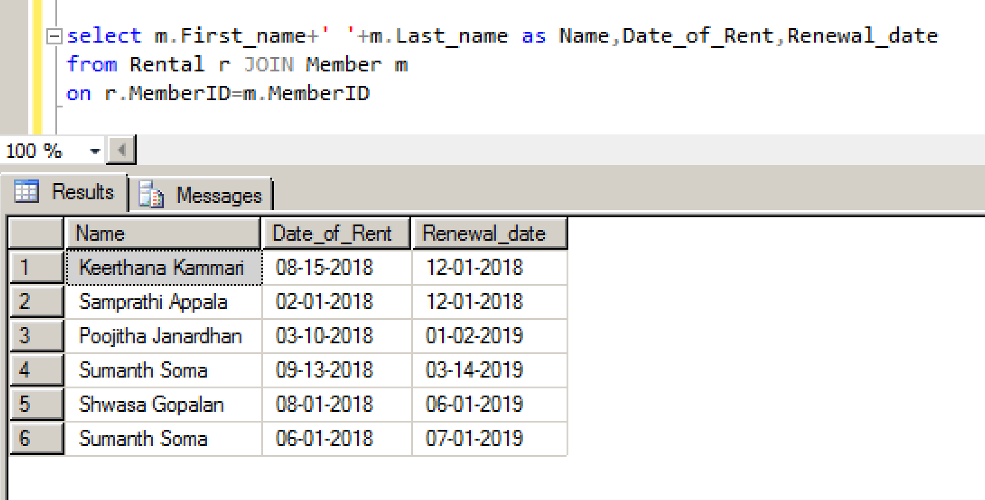

3. select count(RentID) as No_of_Rents, m.MemberID,m.First_name+' '+m.Last_name as Member_Name

from Rental r JOIN Member m

on r.MemberID=m.MemberID

group by m.MemberID,m.First_name,m.Last_name

order by No_of_Rents Desc

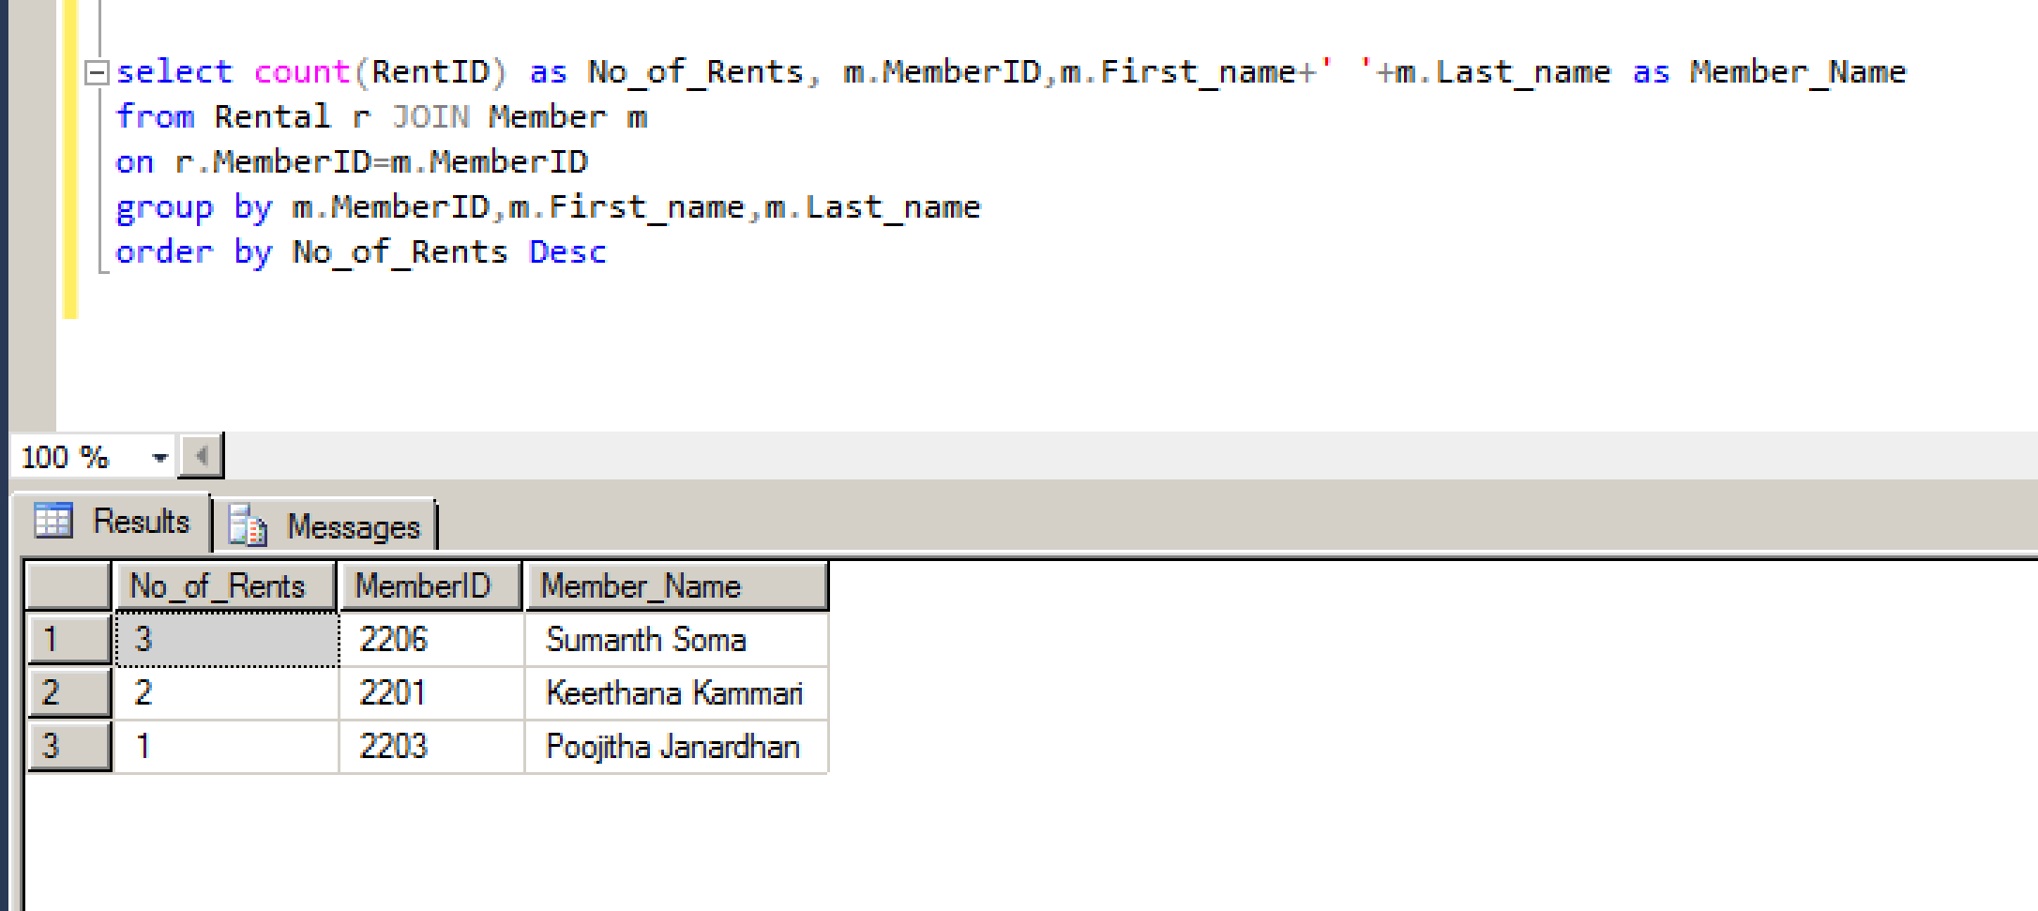

4.select m.First_name+' '+m.Last_name as MemberName

from Ebooks e,OrderDetails o,Rental r,Member m

where e.e_bookID=o.e_bookID and o.RentID=r.RentID and r.MemberID=m.MemberID

and File_size>21

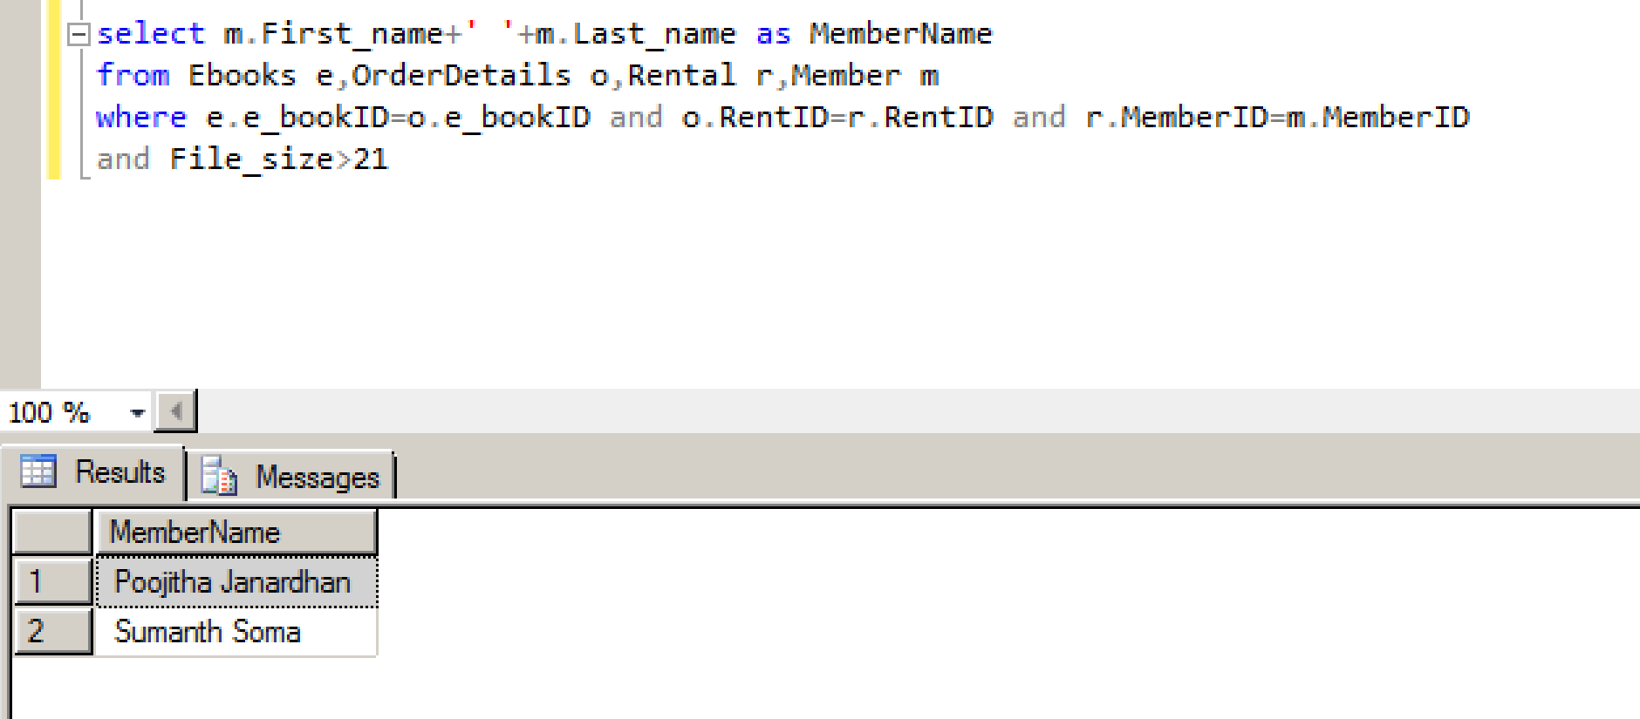

5.select count(b.ISBN) as No_Of_Books from Books b,OrderDetails o,Order_Rating orr

where b.ISBN=o.ISBN and o.OrderID=orr.OrderID and Review like '%good%'

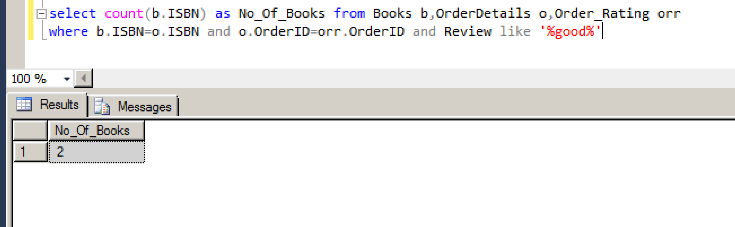

6.Book and supplier details

select BookName,s.Supplier_name

from Books b,Suppliers s

where b.SupplierID=s.SupplierID

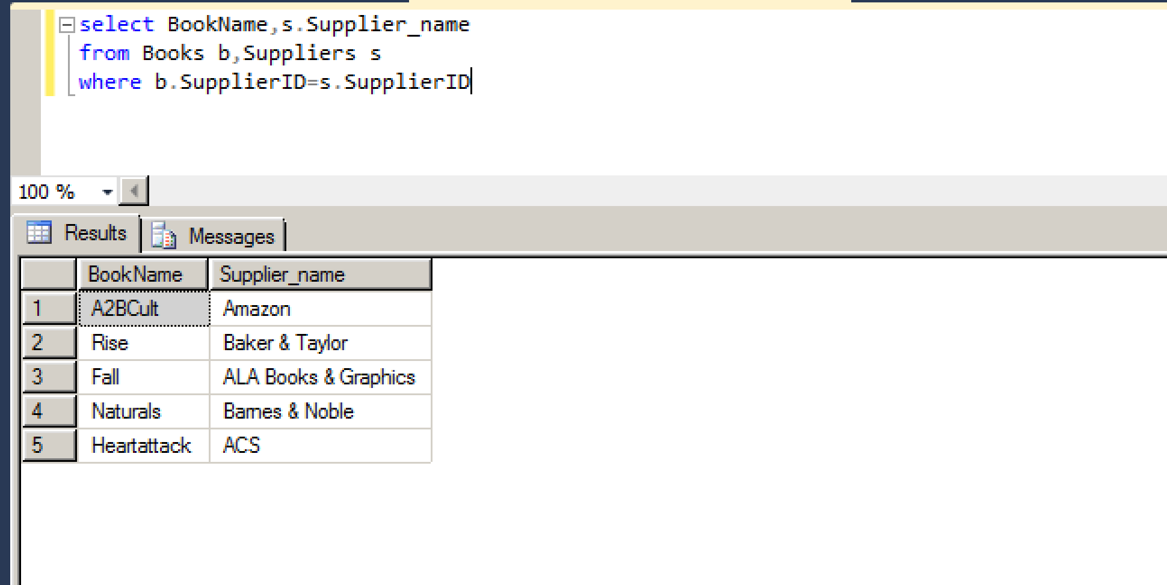

7.Contact details of book renewal date greater than today’s date(2nd dec 2018)

select distinct m.First_name+' '+m.Last_name as Member_Name,Phone,Email_id from Rental r,Member m

where r.MemberID=m.MemberID and Renewal_date>GETDATE()

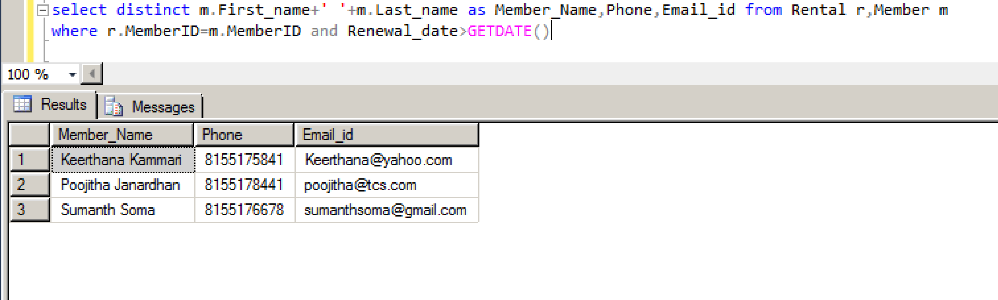

8.PublisherName and SupplierName whose publication are Pearson

select p.Publisher_name,s.Supplier_name,b.Publication

from Publishers p,Suppliers_Publishers sp,Suppliers s,Books b

where p.PublisherID=sp.PublisherID

and sp.SupplierID=s.SupplierID

and s.SupplierID=b.SupplierID

and Publication like 'Pearson'

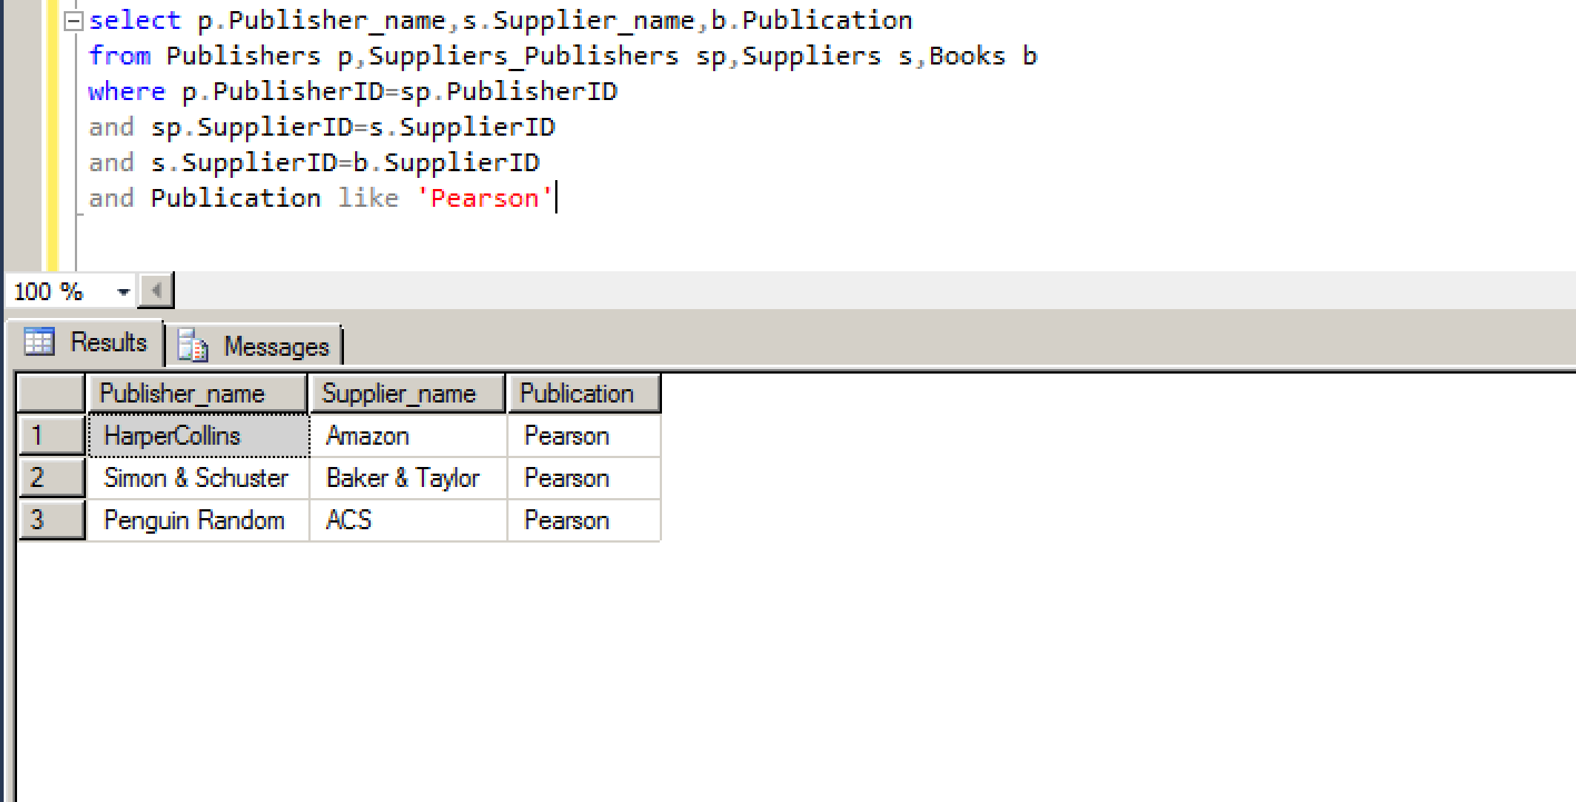

9.List out the Members with given comments

select m.MemberID,First_name+' '+Last_name as MemberName,Comments

from Member m LEFT JOIN FeedBack f

on m.MemberID=f.MemberID

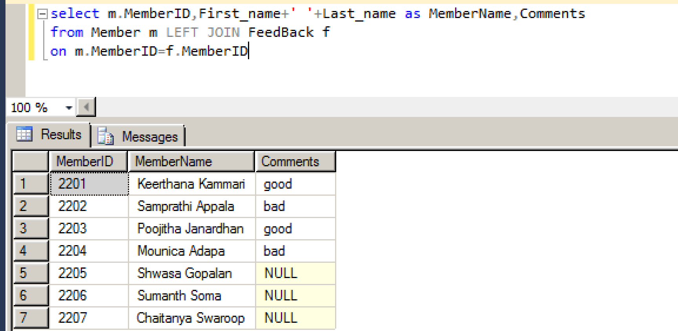

10.

select Name from Store

where zipcode like

(select zipcode from Member

intersect

select Zipcode from Store)

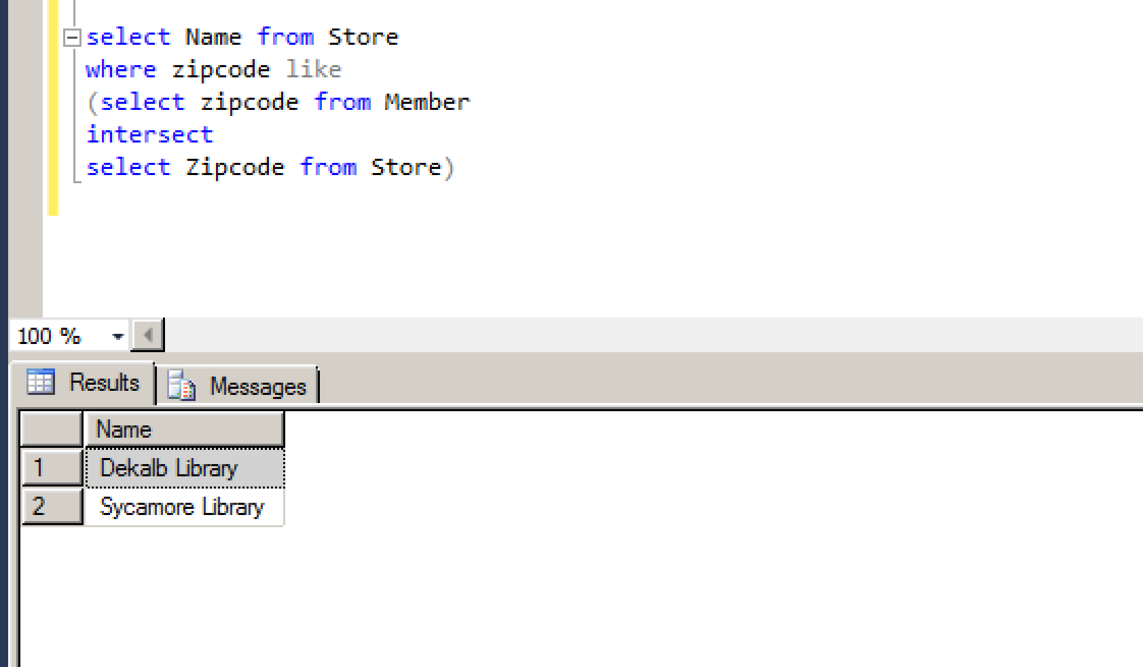

11. SELECT mb.MembershipID

,mm.First_name

,Type_of_membership

FROM Member mm

JOIN Membership mb

ON mm.MemberID = mb.MemberID

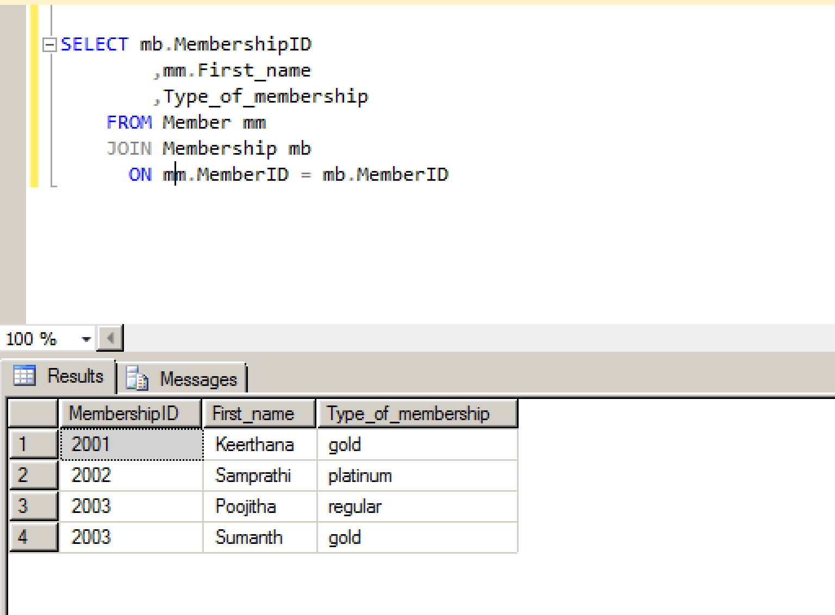

12. SELECT bk.BookName

,q.member_name

FROM Books bk

JOIN OrderDetails od

ON bk.ISBN = od.BookID

JOIN Rental rt

ON rt.RentID = od.RentID

JOIN (

select m.First_name+' '+m.Last_name as member_name

, m.MemberID

from Member m

) q

ON q.MemberID = rt.MemberID

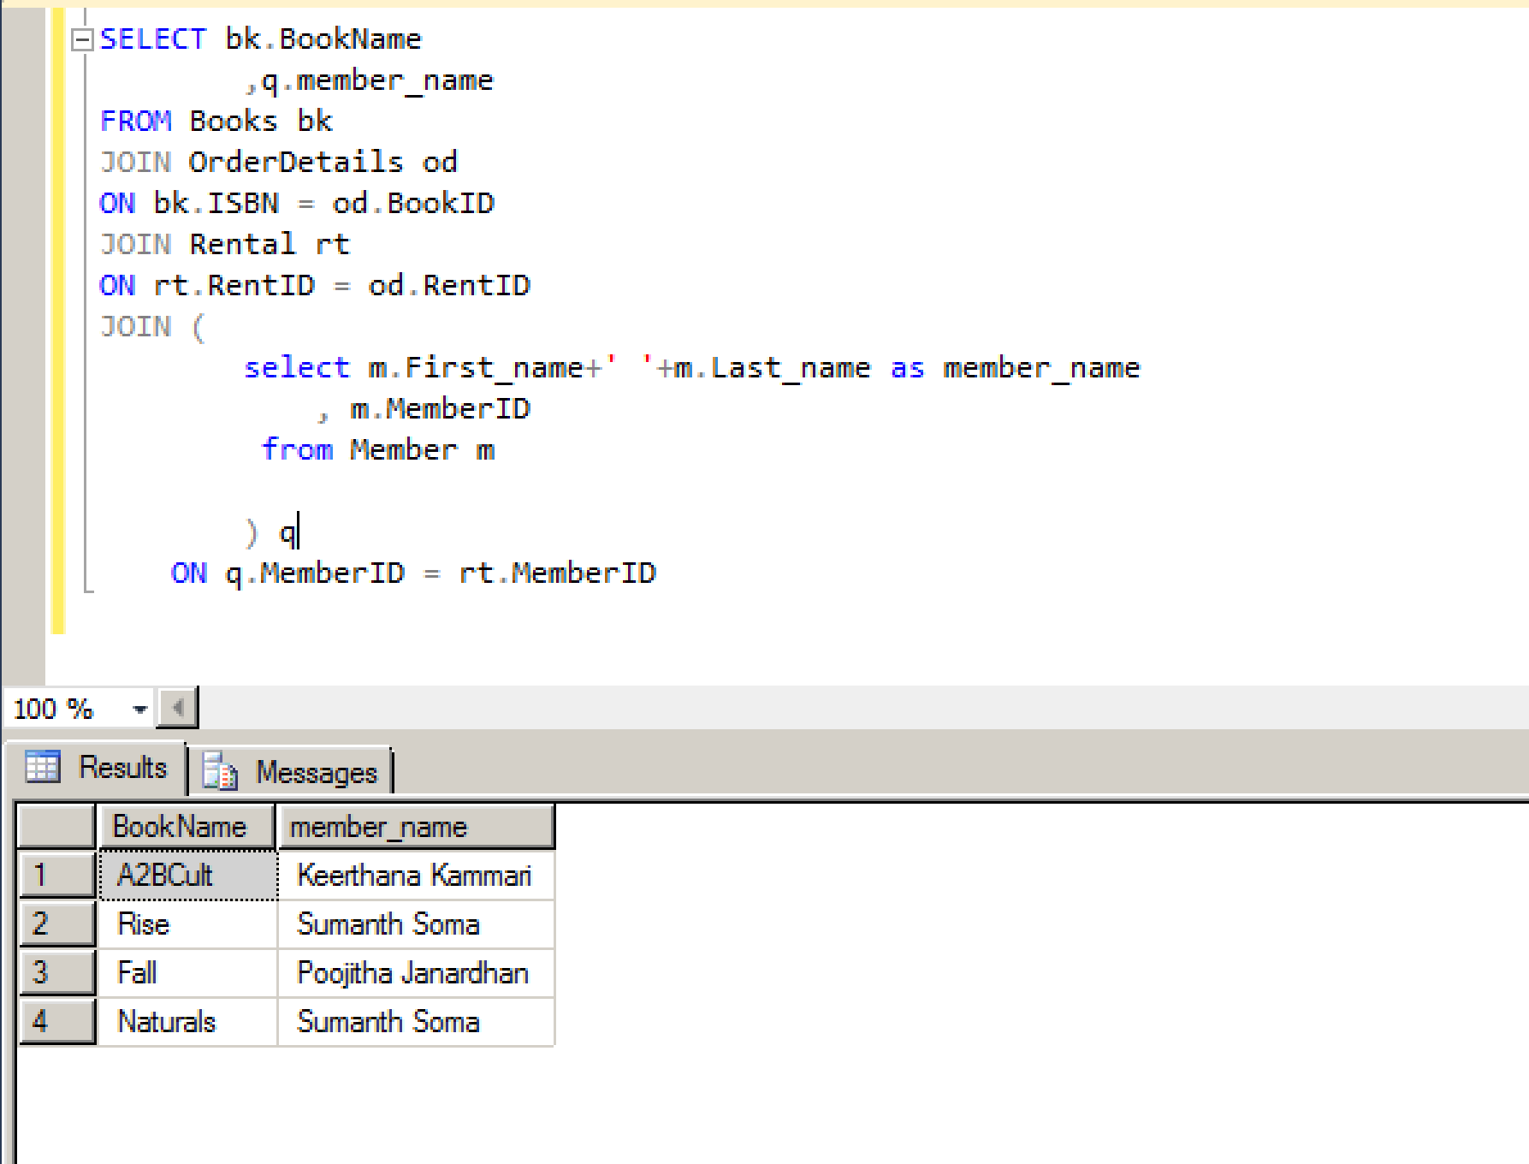

13. SELECT bk.BookName, bk.Author

FROM Books bk

JOIN Suppliers sp

ON bk.SupplierID = sp.SupplierID

JOIN Suppliers_Publishers sb

ON sb.SupplierID = sp.SupplierID

WHERE sb.PublisherID IN

(select pb.PublisherID

from Publishers pb

where pb.Publisher_name = 'Bloomsbury')

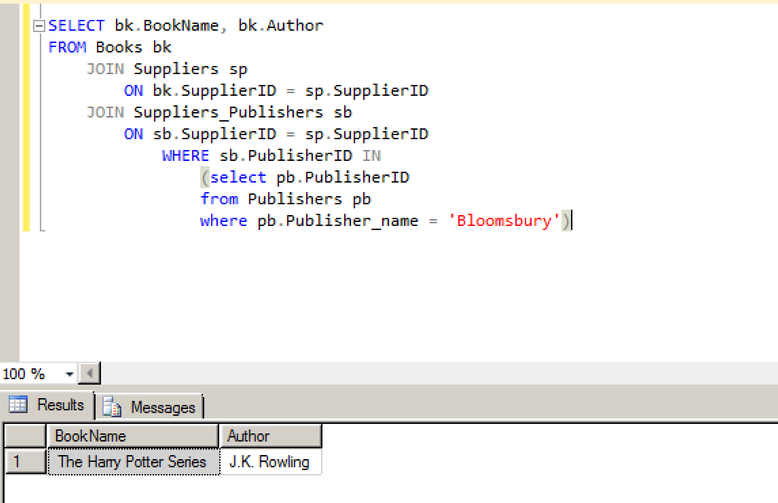

14. SELECT pb.Publisher_name

FROM Publishers pb

JOIN Suppliers_Publishers sb

ON pb.PublisherID = sb.PublisherID

JOIN Suppliers sp

ON sp.SupplierID = sb.SupplierID

WHERE sb.SupplierID IN

(select b.SupplierID

from Books b

where b.BookName = 'The Castle')

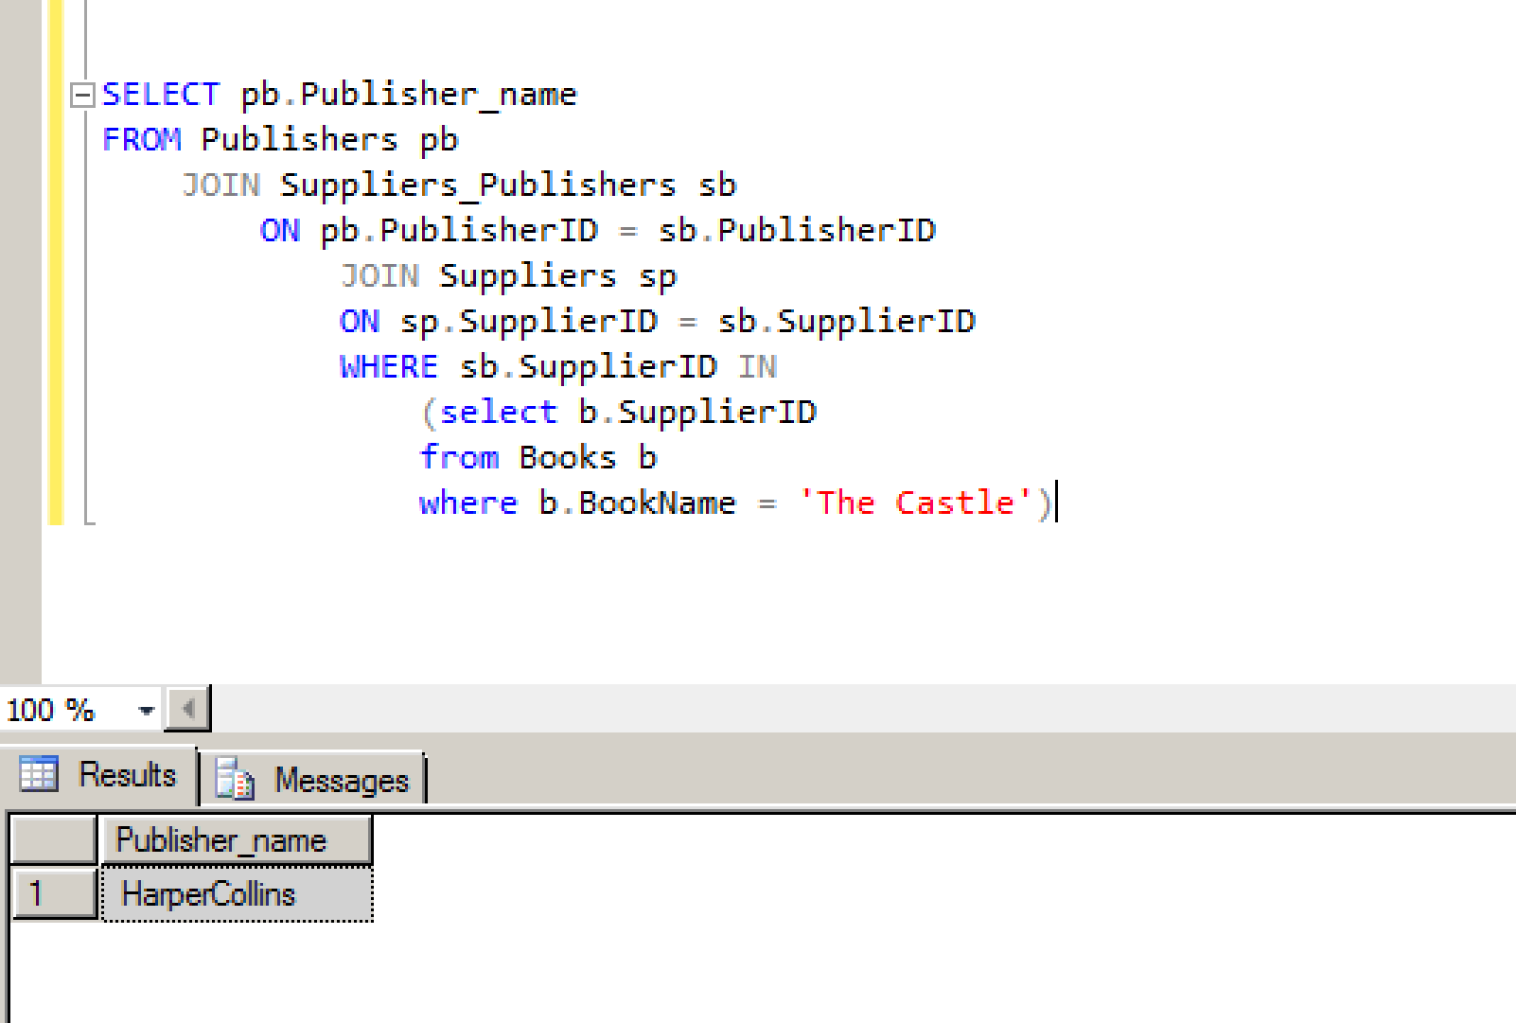

15.

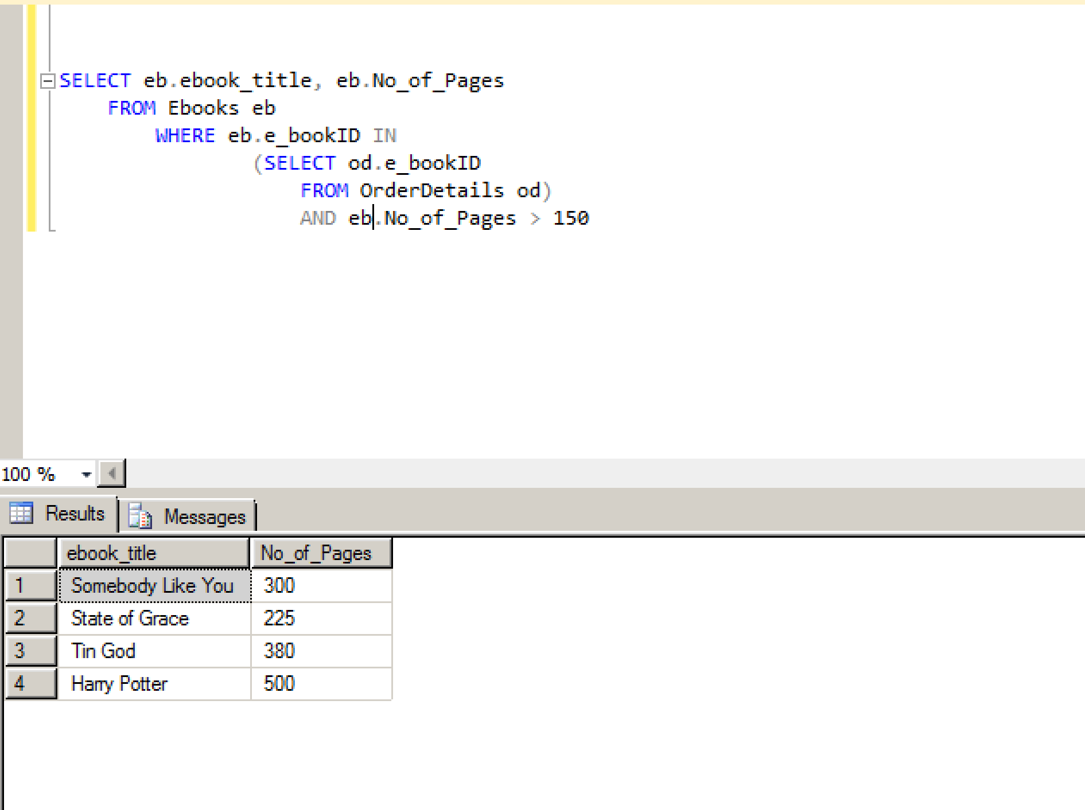

16.select o.OrderID,OrderDate,Rating,Review

from OrderDetails o LEFT JOIN Order_Rating orr

on o.OrderID=orr.OrderID

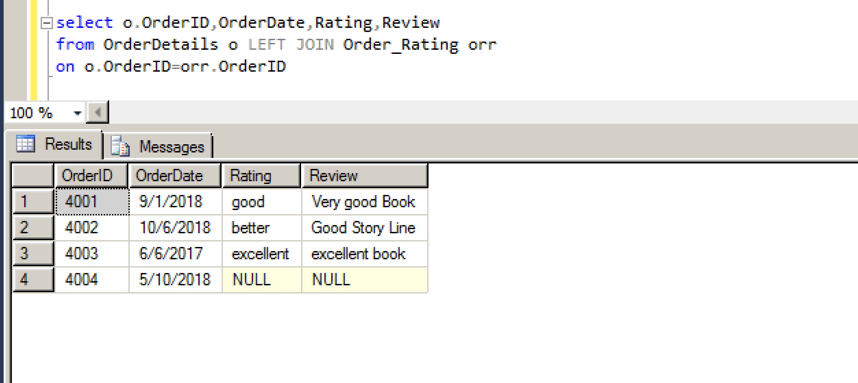

17.

select First_name,Last_name,Phone,Email_id,BookName,OrderDate,Renewal_date from

Books b LEFT JOIN OrderDetails o

on b.ISBN=o.ISBN

LEFT JOIN Rental r

on r.RentID=o.RentID

RIGHT JOIN Member m

on m.MemberID=r.MemberID

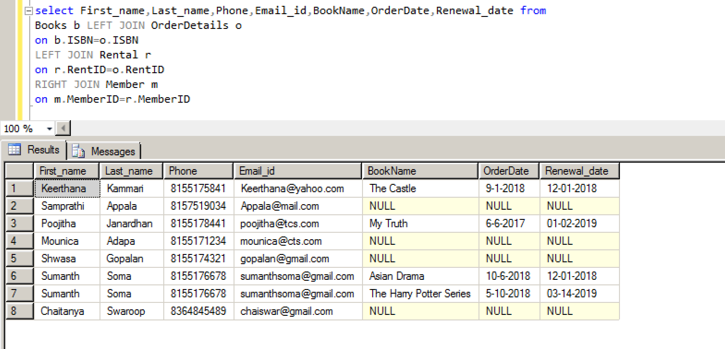

18. Display all the Authors of Books and EBooks

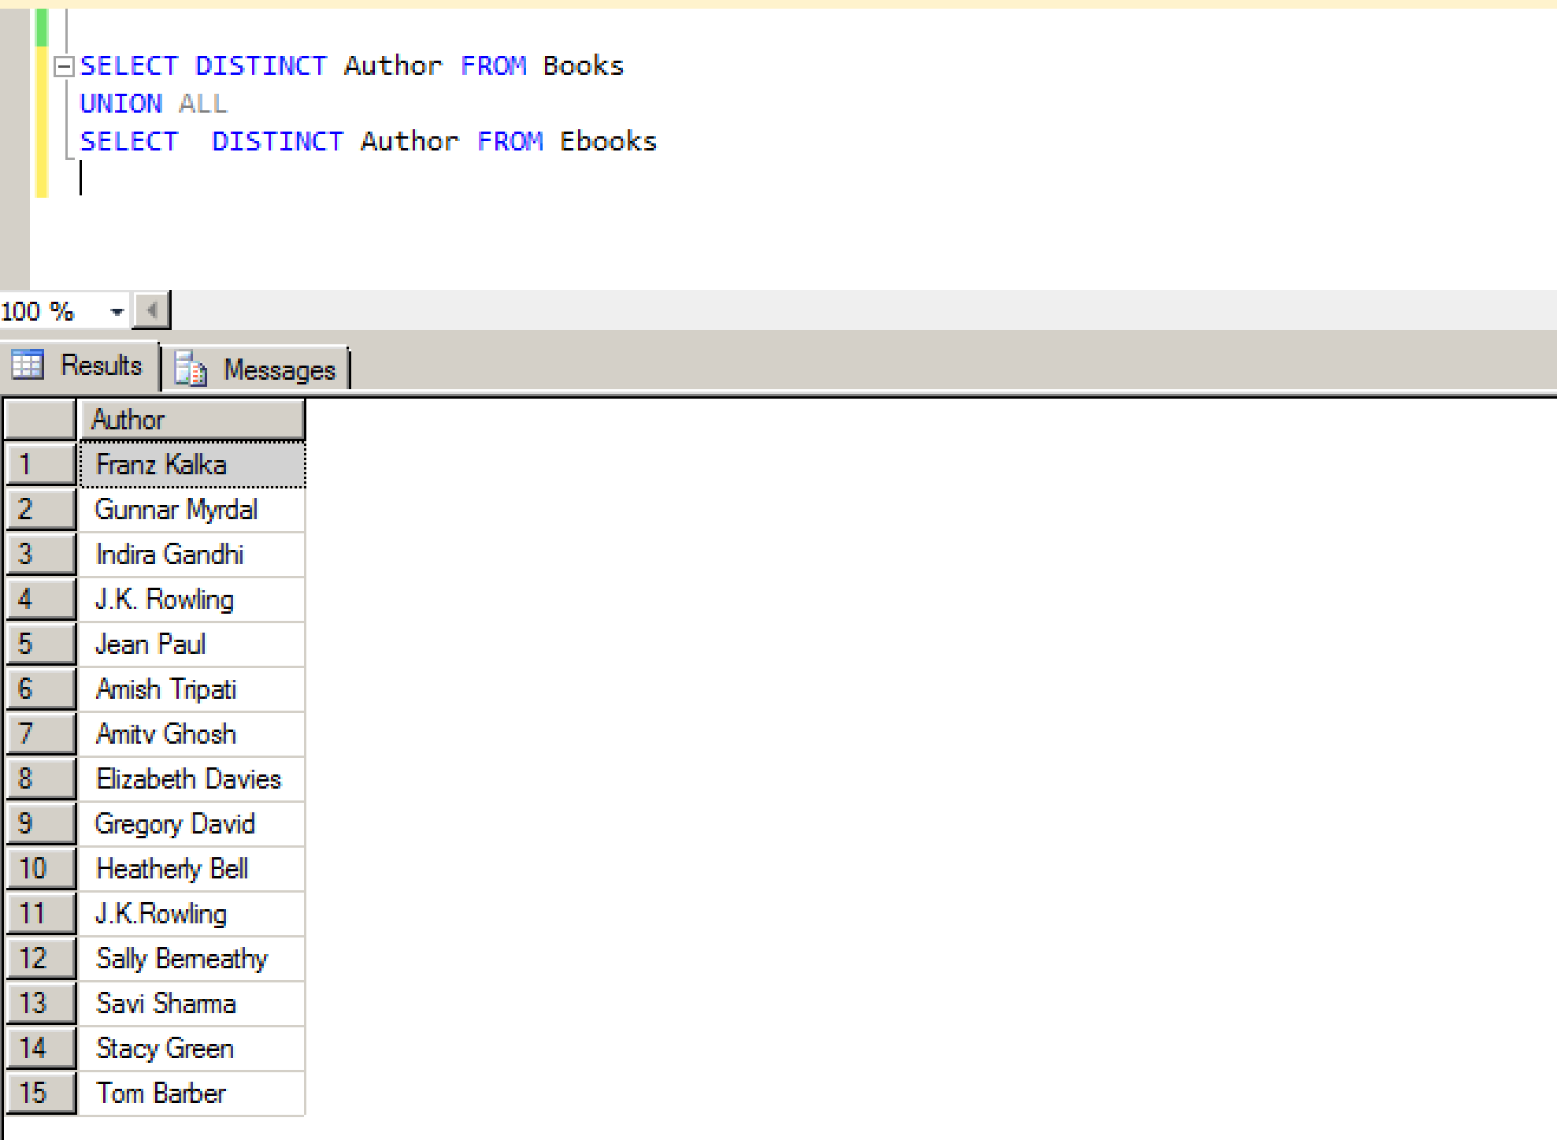

19. List of all the Suppliers who supply books to all the publishers

SELECT Supplier_name FROM Suppliers

WHERE SupplierID

IN (

SELECT SupplierID FROM Suppliers_Publishers)

